SIMATS ENGINEERING
ASSESSMENT TOOL 1
COURSE NAME: Artificial Intelligence COURSE CODE: CSA17

COURSE OUTCOME COVERED
CO1: Apply AI basics such as intelligent agents and uninformed search methods to solve problems effectively. (BL3)
Assessment Tool Weightage: 35%

QUESTIONS: 5 Duration : 1 Hour
Total Marks:50
Annexure A
Analytical Problem Solving

Code of Conduct:
I P.Revanthsai / 192525451 (Name / Reg No) certify that this submission is my original work and that I have adhered to the guidelines specified for this assessment.
I understand that any violation of academic integrity rules will result in disciplinary action.
Signature of the student:

Annexure A
Analytical Problem Solving
Question 1
1. Solve the Water Jug problem: you are given 2 jugs, a 4-gallon one and 3-gallon one. Neither has any measuring marker on it. There is a pump that can be used to fill the jugs with water. How can you get exactly 2 gallons of water into 4-gallon jug? Explicit assumptions: A jug can be filled from the pump, water can be poured out of a jug onto the ground, water can be poured from one jug to another and that there are no other measuring devices available.
Answer:
1.1 Problem Understanding
The Water Jug problem is a classic state-space search problem. We have a 4-gallon jug and a 3-gallon jug with no markings, an unlimited supply of water from a pump, and the freedom to empty a jug on the ground or pour one jug into the other. The requirement is to end with exactly 2 gallons in the 4-gallon jug; the amount left in the 3-gallon jug does not matter.
Since neither jug has markings, the only quantities we can measure exactly are “completely full” and “completely empty”. Every useful move therefore either fills a jug, empties a jug, or pours from one jug into the other until the source is empty or the destination is full. The puzzle is solved by choosing a sequence of such moves.
1.2 Problem Formulation
- State representation: an ordered pair (x, y), where x = gallons in the 4-gallon jug (0 ≤ x ≤ 4) and y = gallons in the 3-gallon jug (0 ≤ y ≤ 3). The state space has 5 × 4 = 20 possible states.
- Initial state: (0, 0), both jugs empty.
- Goal state: (2, n) for any n, i.e. exactly 2 gallons in the 4-gallon jug.
- Actions (operators): fill a jug, empty a jug, pour from one jug into the other (listed as production rules below).
- Transition model: a rule is applicable only if its condition holds; it produces the new state shown.
- Path cost: each action costs 1, so the cost of a solution is the number of steps.
1.3 Production Rules
The following production rules (condition → action) define the operators of the search problem:
Rule | Condition | Resulting state | Meaning
1 | x < 4 | (4, y) | Fill the 4-gallon jug from the pump
2 | y < 3 | (x, 3) | Fill the 3-gallon jug from the pump
3 | x > 0 | (x − d, y) | Pour some water (d) out of the 4-gallon jug
4 | y > 0 | (x, y − d) | Pour some water (d) out of the 3-gallon jug
5 | x > 0 | (0, y) | Empty the 4-gallon jug on the ground
6 | y > 0 | (x, 0) | Empty the 3-gallon jug on the ground
7 | x + y ≥ 4 and y > 0 | (4, y − (4 − x)) | Pour from the 3-gal jug into the 4-gal jug until the 4-gal jug is full
8 | x + y ≥ 3 and x > 0 | (x − (3 − y), 3) | Pour from the 4-gal jug into the 3-gal jug until the 3-gal jug is full
9 | x + y ≤ 4 and y > 0 | (x + y, 0) | Pour all the water from the 3-gal jug into the 4-gal jug
10 | x + y ≤ 3 and x > 0 | (0, x + y) | Pour all the water from the 4-gal jug into the 3-gal jug

Rules 3 and 4 (pouring away an arbitrary amount) are never needed because we cannot measure an arbitrary amount; the useful rules are 1, 2, 5, 6, 7, 8, 9 and 10.
1.4 Solution (Solution 1)
Starting from (0, 0) and applying the rules in the order below, we reach (2, 0) in six steps:
Step | State (x, y) | Rule applied | Action performed
0 | (0, 0) | — | Initial state: both jugs empty
1 | (0, 3) | Rule 2 | Fill the 3-gallon jug from the pump
2 | (3, 0) | Rule 9 | Pour all of the 3-gallon jug into the 4-gallon jug
3 | (3, 3) | Rule 2 | Fill the 3-gallon jug again
4 | (4, 2) | Rule 7 | Pour from the 3-gallon jug into the 4-gallon jug until it is full; 1 gallon goes in, so 2 gallons remain in the 3-gallon jug
5 | (0, 2) | Rule 5 | Empty the 4-gallon jug on the ground
6 | (2, 0) | Rule 9 | Pour the 2 gallons from the 3-gallon jug into the 4-gallon jug. Goal reached

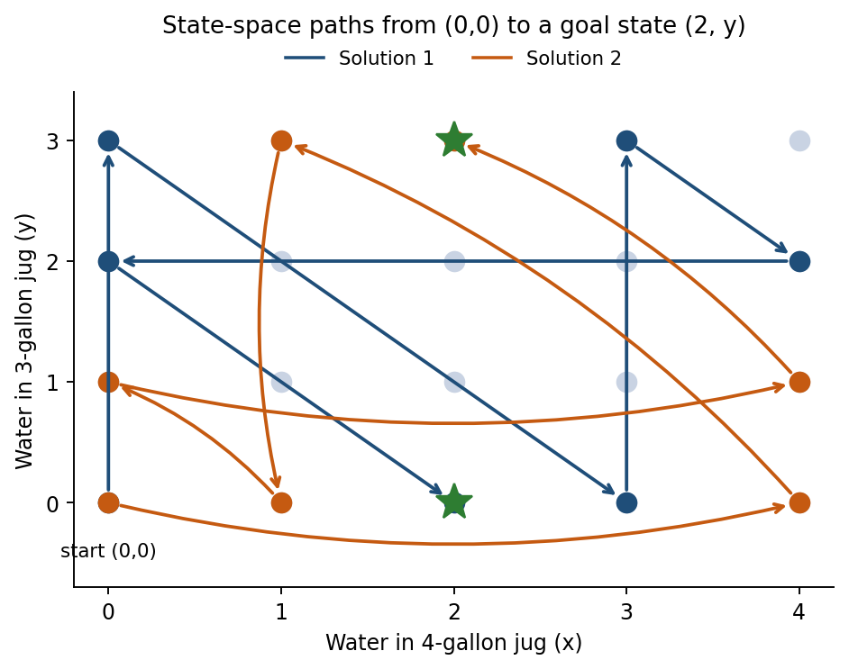
Figure 1: Both six-step solution paths in the (x, y) state space
1.5 Alternative Solution (Solution 2)
Filling the 4-gallon jug first gives a second, equally short solution that finishes with (2, 3):
Step | State (x, y) | Rule applied | Action performed
1 | (4, 0) | Rule 1 | Fill the 4-gallon jug
2 | (1, 3) | Rule 8 | Pour from the 4-gallon jug into the 3-gallon jug until it is full (1 gallon left in the 4-gal jug)
3 | (1, 0) | Rule 6 | Empty the 3-gallon jug
4 | (0, 1) | Rule 10 | Pour the 1 gallon from the 4-gallon jug into the 3-gallon jug
5 | (4, 1) | Rule 1 | Fill the 4-gallon jug again
6 | (2, 3) | Rule 8 | Pour from the 4-gallon jug into the 3-gallon jug (needs 2 more gallons). Goal reached
1.6 Search Strategy and Analysis
The problem can be solved mechanically with Breadth-First Search (BFS), which expands states level by level and is guaranteed to find the shortest solution when every step costs 1. The BFS levels from (0, 0) are:
Depth | New states discovered
0 | (0,0)
1 | (4,0), (0,3)
2 | (4,3), (1,3), (3,0)
3 | (1,0), (3,3)
4 | (0,1), (4,2)
5 | (4,1), (0,2)
6 | (2,3) and (2,0): goal states

BFS shows that 6 steps is the minimum, so both solutions above are optimal. Of the 20 states in the space, 14 are reachable from (0, 0); the states (1,1), (2,1), (3,1), (3,2), (1,2) and (2,2) can never be reached. A Depth-First Search would also find a solution, but not necessarily the shortest, and it needs a visited-state check to avoid looping between states such as (0,3) and (3,0).
Conclusion: exactly 2 gallons can be placed in the 4-gallon jug in six steps using the sequence (0,0) → (0,3) → (3,0) → (3,3) → (4,2) → (0,2) → (2,0).

Question 2
2. Find out how Mars Rover, analyse and explore the samples on Mars by answering the following questions. i. What are the percept’s for this agent? ii. Characterize the operating environment. iii. What are the actions the agent can take? iv. How can one evaluate the performance of the agent? v. What sort of agent architecture do you think is most suitable for this agent? Why?
Answer:
2.0 Introduction
A Mars rover is an autonomous (or semi-autonomous) intelligent agent: it perceives the Martian surface through sensors and acts on it through actuators in order to explore the terrain and to collect, analyse and report soil and rock samples. Because radio signals take roughly 4 to 24 minutes to travel between Earth and Mars, the rover cannot be driven in real time and must make many decisions on its own. The task description is organised using the PEAS framework (Performance measure, Environment, Actuators, Sensors).
i. Percepts of the Agent
Percepts are the inputs the agent receives from its sensors at any instant:
Sensor group | Percepts obtained
Vision | Stereo/navigation camera images, panoramic and close-up (microscopic) images of rocks and soil, sky and sun position
Science instruments | Spectrometer readings (chemical and mineral composition), X-ray / laser readings, moisture and organic-compound traces
Motion and position | Wheel odometry, inertial (IMU) readings, tilt/inclination, sun-sensor heading, visual odometry (there is no GPS on Mars)
Hazard sensing | Obstacle proximity, wheel slip, wheel/arm motor current and torque, terrain roughness
Environment | Ambient temperature, wind speed, atmospheric pressure, dust opacity, light level (day/night)
Internal state | Battery charge, solar-panel/RTG power output, component temperatures, memory and storage left, fault flags
Communication | Commands and updated targets uplinked from Earth, link-availability windows of orbiters
ii. Characterisation of the Operating Environment
Property | Classification | Reason
Observability | Partially observable | Cameras see only a limited range; the rover cannot see behind rocks, under sand, or the true composition of unsampled material
Agents | Single agent | The rover is the only agent acting on the terrain (orbiters and Earth control only support it)
Determinism | Stochastic | Wheel slip, loose sand, sensor noise and dust storms mean an action does not always have the intended effect
Episodic / sequential | Sequential | Current actions (spending power, moving to a site, drilling) affect all later decisions
Static / dynamic | Dynamic | Lighting, temperature, dust and wind change while the rover is deliberating
Discrete / continuous | Continuous | Positions, speeds, temperatures and spectra are continuous values
Known / unknown | Largely unknown | The terrain is new and only coarsely mapped from orbit, so the agent has to learn the map as it goes

The environment is therefore partially observable, stochastic, sequential, dynamic, continuous and unknown (single-agent), one of the hardest classes of task environments. It also has long communication delays, extreme temperature swings and limited energy.
iii. Actions of the Agent
- Locomotion: move forward/backward, steer or turn on the spot, stop, climb, back out of a hazard, tilt/orient the vehicle.
- Sensing actions: take images (navigation, panoramic, close-up), point the mast camera, switch spectrometers on and acquire a reading.
- Sample handling: extend the robotic arm, brush or abrade a rock surface, drill, scoop soil, deliver the sample to an on-board lab, seal and store a sample in a cache tube.
- Analysis: run chemical/mineral analysis, compress and prioritise data.
- Communication: transmit data to an orbiter or to Earth, receive and acknowledge commands.
- Housekeeping: recharge (orient solar panels or idle), heat components, enter sleep or safe mode, reboot or run diagnostics.
iv. Evaluating the Performance of the Agent
The performance measure should reward mission success while penalising risk and waste. A weighted combination of the following can be used:
Criterion | How it is measured
Scientific value | Number of valid, distinct samples analysed and their scientific priority (e.g. signs of water or organics)
Coverage | Area explored and distance travelled toward target sites
Safety / survival | Time the rover remains operational; number of collisions, tip-overs, entrapments or safe-mode events (penalty)
Energy efficiency | Science done per unit of battery energy used
Data return | Quantity and quality of data successfully transmitted to Earth
Time efficiency | Mission time needed to complete each goal; fraction of sols that are productive

For example, Performance = w₁·(valid samples) + w₂·(area explored) + w₃·(data returned) − w₄·(hazard incidents) − w₅·(energy wasted), where the weights are set by the mission team. Because a single failure can end the mission, safety carries a heavy weight.
v. Most Suitable Agent Architecture
The best choice is a goal-based, utility-based agent built on a model-based reflex core, organised as a layered (hybrid) architecture:
- Model-based reflex layer (safety): because the environment is only partially observable, the rover keeps an internal model (terrain map, position, power and health). Condition–action rules such as “if tilt exceeds limit then stop” or “if battery below threshold then sleep” react instantly, which is vital since Earth cannot intervene in time.
- Goal-based layer: the rover has explicit goals (reach a target outcrop, drill, analyse) and uses search/planning to choose sequences of actions that achieve them.
- Utility-based layer: many goals compete for limited energy and time; a utility function trades off science value against risk and energy so the rover can choose the best option among several.
- Learning component: improves terrain classification and slip prediction from experience.
A simple reflex agent would fail because the environment is partially observable and goals matter; a purely goal-based agent cannot weigh safety against science. The layered design combines fast reactions with deliberate planning.
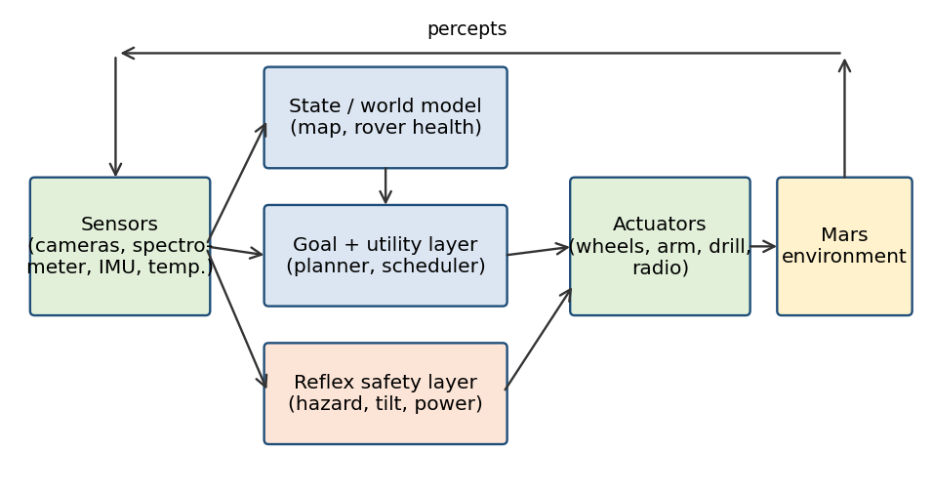
Figure 2: Layered goal/utility-based architecture for the Mars rover
Conclusion: the Mars rover is a partially observable, stochastic, dynamic, continuous single-agent problem, best served by a hybrid goal- and utility-based agent with a model-based reflex safety layer.

Question 3
3. Explore the search space using search strategies and formulate the problem components for the 8-Queens problem using the following information: Place 8 queens on a chessboard such that none of the queen’s attack any of the others. A configuration of 8 queens on the board as shown in the figure below, but this does not represent a solution as the queen in the first column is on the same diagonal as the queen in the last column.
Answer:
3.1 Problem Understanding
The 8-Queens problem asks us to place eight queens on an 8 × 8 chessboard so that no two queens attack each other. A queen attacks any piece in the same row, the same column or on the same diagonal. A valid solution therefore has exactly one queen in every row and column and no two queens on a common diagonal. The configuration in the question is not a solution because the queens in the first and last columns lie on the same diagonal, as in Figure 3(a).
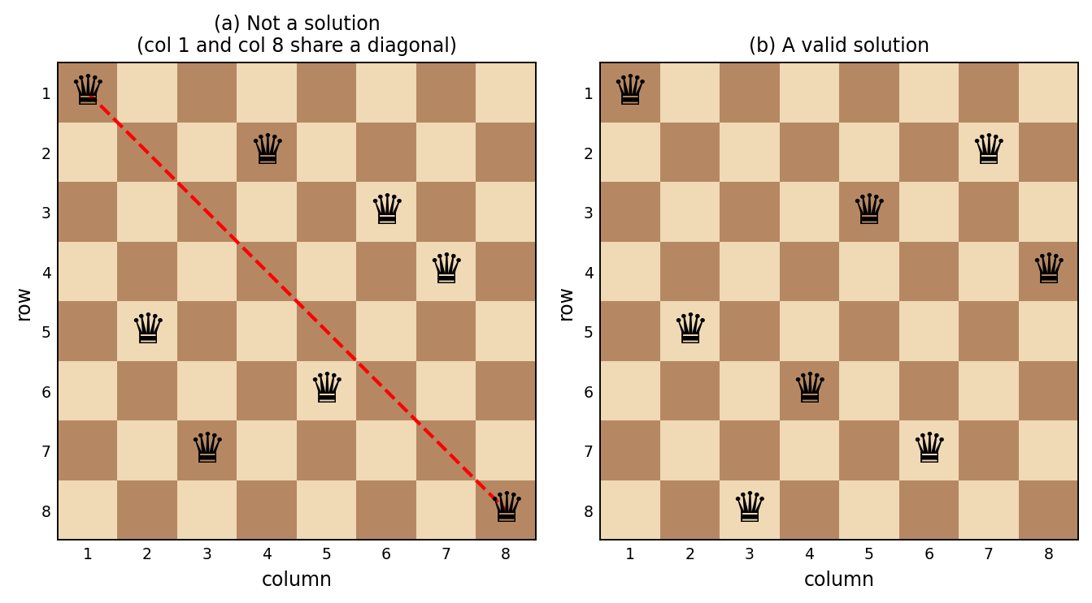
Figure 3: (a) A configuration that fails because two queens share a diagonal; (b) a valid solution
3.2 Formulating the Problem Components
Two common formulations are used.
Formulation 1: Complete-state formulation
- States: all arrangements of 8 queens on the board, one per column (≈ 8⁸ = 16.7 million) or any 8 squares (≈ 1.8 × 10¹⁴).
- Initial state: all 8 queens already placed (for example, one per column at random rows).
- Actions: move a queen to another square in its column.
- Goal test: no pair of queens attacks each other.
Formulation 2: Incremental formulation (recommended for uninformed search)
- States: any arrangement of 0 to 8 queens on the board in which no queen attacks another. Queens are added column by column.
- Initial state: the empty board with no queens.
- Actions: add a queen to the leftmost empty column in a row where it is not attacked by any queen already on the board.
- Transition model: returns the board with the new queen added.
- Goal test: 8 queens are on the board and none is attacked.
- Path cost: not relevant, since only the final configuration matters (each action can be given cost 1).
With the “non-attacking, leftmost column” restriction the state space shrinks dramatically: the naive version has 64 × 63 × … × 57 ≈ 1.8 × 10¹⁴ states, a one-queen-per-column version has 8⁸ ≈ 1.7 × 10⁷, a permutation version has 8! = 40,320, and the incremental non-attacking version has only 2,057 states. Choosing a good formulation matters as much as choosing a good algorithm.
3.3 Exploring the Search Space with Search Strategies
The search tree of the incremental formulation has root = empty board, and each node at depth d has queens in the first d columns. The depth of a solution is exactly 8.
Strategy | How it works on 8-Queens | Properties
Breadth-First Search (BFS) | Expands all boards with k queens before any with k + 1 queens | Complete; stores a very large frontier (exponential memory). Not practical for large n
Depth-First Search / Backtracking | Places a queen in column 1, then column 2 and so on; when a column has no safe row, it backtracks to the previous column | Memory is only O(depth) = O(8); finds a solution quickly; not optimal, but optimality is irrelevant here
Depth-Limited Search | DFS with limit 8 (all solutions lie at depth 8) | Complete, because the solution depth is known to be 8
Iterative Deepening (IDDFS) | Repeats depth-limited search with limits 0, 1, 2, … 8 | Complete and with DFS-like memory; the repeated work is small
Uniform Cost Search | With equal step costs it behaves like BFS | Same drawbacks as BFS

Backtracking trace (first steps). Rows are numbered 1 to 8, and (c, r) means a queen in column c and row r:
- Place Q1 at (1,1).
- Column 2: rows 1 and 2 are attacked; place Q2 at (2,3).
- Column 3: rows 1, 2, 3, 4 and 5 are attacked; place Q3 at (3,5).
- Column 4: rows 2 and 4 are free, but Q4 at (4,2) leaves later columns without a safe square; continue and backtrack when a column has no safe row.
- Backtrack, change the most recent queen to the next safe row, and repeat until all 8 columns are filled.

The search order and pruning give the first solution (rows by column) [1, 5, 8, 6, 3, 7, 2, 4], shown in Figure 3(b). There are 92 solutions in total, of which 12 are distinct once rotations and reflections are treated as the same.
Pseudocode: backtracking search
function PLACE-QUEENS(col, board):
if col = 8 then return board // goal test: all columns filled
for each row in 1..8 do
if SAFE(board, row, col) then // no clash in row/diagonal
board[col] ← row
result ← PLACE-QUEENS(col + 1, board)
if result ≠ failure then return result
board[col] ← none // backtrack
return failure

function SAFE(board, row, col):
for c in 1..col-1 do
if board[c] = row or |board[c] − row| = |c − col| then
return false
return true

Conclusion: the problem is best formulated incrementally; depth-first backtracking (or IDDFS) explores the 2,057-state space efficiently and finds a valid arrangement such as [1, 5, 8, 6, 3, 7, 2, 4], whereas the configuration in the question is rejected by the goal test because two queens share a diagonal.

Question 4
4. A customer wants to travel from the one location to another location using OLA Cab booking mobile application. The customer can select the any of the cab type as mini, micro, sedan, shared, prime and so on based on his comfort to reach the destination. Identify what type of problem-solving agent can be used and write the pseudocode for the above problem.
Answer:
4.1 Problem Understanding
The customer gives a pickup location and a destination and chooses among several cab types (Micro, Mini, Sedan, Prime, Shared, and so on). Each option differs in comfort, fare, waiting time and trip time. The application must therefore decide which cab, and which route, should be booked so that the passenger reaches the destination in the way that best fits the stated preference. The problem is a sequential decision problem with a clear goal (“be at the destination”) and several ways of achieving it with different costs.
4.2 Type of Agent: Goal-Based (Utility-Based) Problem-Solving Agent
The most suitable agent is a goal-based problem-solving agent that uses a utility function to compare alternatives:
- Goal-based: it has an explicit goal state, “customer at destination”, and searches for a sequence of actions (select cab → accept ride → travel along route) that reaches it. A simple reflex agent cannot do this because the right action depends on the future.
- Utility-based: several cabs reach the goal, so goal achievement alone is not enough. The agent measures how good each option is, using fare, estimated time of arrival (ETA), comfort and the customer’s preference, and picks the one with maximum utility (or minimum cost).
- Problem-solving cycle: it follows the standard steps of formulate goal → formulate problem → search → execute, and re-plans if the situation changes (cab cancelled, traffic jam, fare surge).
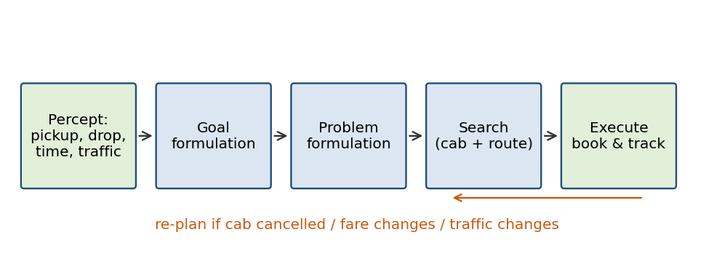
Figure 4: Problem-solving cycle of the cab-booking agent
4.3 PEAS Description
Element | Description
Performance measure | Low fare, short waiting and travel time, passenger comfort and safety, high customer satisfaction, successful trip completion
Environment | Road network, live traffic, available drivers/cabs, weather, customer preferences (partially observable, dynamic, stochastic, sequential)
Actuators | Display cab options and fares, confirm booking, assign driver, share route and ETA, process payment, send notifications
Sensors | GPS location of customer and cabs, destination entry, cab type selected, traffic data, fare and surge data, customer rating and feedback
4.4 Problem Formulation
- Initial state: customer at the pickup location, no cab booked.
- Goal state: customer at the destination (trip completed and paid).
- States: (customer location, selected cab type, assigned driver, trip status).
- Actions: SELECT(cab type), BOOK, CANCEL / RE-ASSIGN, PICK-UP, DRIVE(road segment), DROP, PAY.
- Path cost / utility: U(cab) = −(w₁·fare + w₂·ETA + w₃·travel time) + w₄·comfort, with the weights chosen from the customer’s preference (cheapest, fastest, most comfortable).
4.5 Pseudocode
function CAB-BOOKING-AGENT(percept) returns an action
persistent: seq // an action sequence, initially empty
state // description of current world state
goal // initially null
problem // a problem formulation

state ← UPDATE-STATE(state, percept) // pickup, drop, traffic, cabs
if seq is empty then
goal ← FORMULATE-GOAL(state) // customer at DESTINATION
problem ← FORMULATE-PROBLEM(state, goal)
seq ← SEARCH(problem)
if seq = failure then return NO-CAB-AVAILABLE-MESSAGE
action ← FIRST(seq)
seq ← REST(seq)
return action

function SEARCH(problem) returns a sequence of actions
options ← { }
for each cab in {Micro, Mini, Sedan, Prime, Shared, ...} do
if AVAILABLE(cab, pickup) then
route ← BEST-ROUTE(pickup, destination) // A* / UCS
fare ← ESTIMATE-FARE(cab, route)
eta ← ESTIMATE-ETA(cab, pickup)
u ← UTILITY(fare, eta, TRAVEL-TIME(route),
COMFORT(cab), preference)
add (cab, route, u) to options
if options is empty then return failure
best ← the option in options with maximum u
return [SELECT(best.cab), BOOK, PICKUP,
DRIVE(best.route), DROP, PAY]

// Execution loop with re-planning
while customer not at DESTINATION do
percept ← GET-PERCEPT()
if CAB-CANCELLED(percept) or ROUTE-BLOCKED(percept) then
seq ← empty // re-plan
perform CAB-BOOKING-AGENT(percept)
4.6 Worked Example
Suppose the customer wants to go from A to B (10 km). The agent evaluates the available options (illustrative values):
Cab type | Fare (₹) | ETA (min) | Trip time (min) | Comfort (1–5) | Outcome
Shared | 110 | 9 | 32 | 2 | Cheapest, slowest
Micro | 150 | 5 | 25 | 3 | Cheap and quick
Mini | 170 | 4 | 25 | 3 | Balanced
Sedan / Prime | 240 | 6 | 24 | 5 | Most comfortable

If the customer’s preference is low cost, utility is highest for Shared or Micro; if comfort is the preference, Sedan/Prime gives the highest utility. The agent books the cab with maximum utility, then keeps monitoring percepts and re-plans if the cab is cancelled or the route is blocked.
Conclusion: a goal-based, utility-based problem-solving agent is appropriate; it formulates the goal and problem, searches over cab types and routes, books the best option, and re-plans when the environment changes.

Question 5
5. A logistics company operates a delivery network where packages must be transported between warehouses at minimum cost. Each route between warehouses has an associated travel cost (fuel + time). The company wants to determine the least-cost path from the starting warehouse S to the destination warehouse G using the Uniform Cost Search (UCS) algorithm. The delivery network is represented as a weighted graph:
Answer:
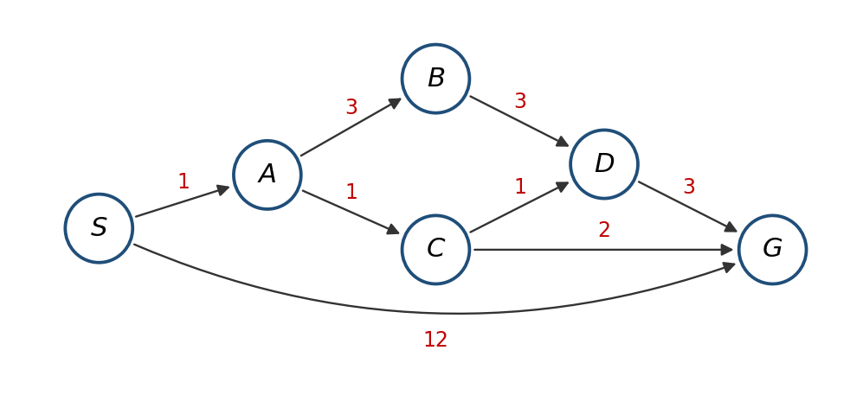
Figure 5: Weighted directed graph of the delivery network
5.1 Problem Understanding
The network has six warehouses S, A, B, C, D and G. Each directed edge carries a cost (fuel + time, in cost units). The aim is to find the path from the start S to the goal G with the minimum total cost. The edges are:
From | To | Cost | From | To | Cost
S | A | 1 | B | D | 3
S | G | 12 | C | D | 1
A | B | 3 | C | G | 2
A | C | 1 | D | G | 3
5.2 Method Selection: Uniform Cost Search
The edges have different costs, so Breadth-First Search (which minimises the number of edges) can return a wrong answer; for example, it would pick the direct route S → G with only one edge but a cost of 12. Uniform Cost Search always expands the frontier node with the lowest path cost g(n) using a priority queue, so the first time the goal is removed from the queue its path is guaranteed to be optimal (when all costs are positive).
Pseudocode of UCS
function UNIFORM-COST-SEARCH(problem) returns a solution or failure
node ← NODE(state = problem.INITIAL, path-cost = 0)
frontier ← priority queue ordered by path-cost, containing node
explored ← empty set
loop do
if frontier is empty then return failure
node ← POP(frontier) // lowest path-cost
if problem.GOAL-TEST(node.state) then return SOLUTION(node)
add node.state to explored
for each action in problem.ACTIONS(node.state) do
child ← CHILD-NODE(problem, node, action)
if child.state not in explored and not in frontier then
INSERT(child, frontier)
else if child.state is in frontier with higher path-cost then
replace that frontier node with child
5.3 Solution Process
Notation: each frontier entry is written as state(g, parent) where g is the path cost from S.
Step | Node expanded (g) | Successors generated | Frontier after step (ordered by g) | Explored set
1 | S (0) | A = 0+1 = 1; G = 0+12 = 12 | A(1), G(12) | {S}
2 | A (1) | B = 1+3 = 4; C = 1+1 = 2 | C(2), B(4), G(12) | {S, A}
3 | C (2) | D = 2+1 = 3; G = 2+2 = 4 (better than 12, so G is updated) | D(3), B(4), G(4) | {S, A, C}
4 | D (3) | G = 3+3 = 6 (worse than 4, discarded) | B(4), G(4) | {S, A, C, D}
5 | B (4) | D = 4+3 = 7 (D already explored, discarded) | G(4) | {S, A, C, D, B}
6 | G (4) | Goal test succeeds: stop | empty | {S, A, C, D, B}

Nodes are expanded in the order S, A, C, D, B and G is reached with cost 4. (If G and B are tied at cost 4, the order between them does not change the answer, because expanding B does not yield a cheaper path to G.)
5.4 Accuracy Check of Alternative Paths
Path from S to G | Calculation | Total cost
S → A → C → G | 1 + 1 + 2 | 4 (minimum)
S → A → C → D → G | 1 + 1 + 1 + 3 | 6
S → A → B → D → G | 1 + 3 + 3 + 3 | 10
S → G (direct) | 12 | 12
5.5 Interpretation of Results
- Optimal path: S → A → C → G with a total cost of 4 units (fuel + time).
- The direct route S → G has the fewest edges but is three times costlier (12 units), so the company saves 8 cost units (about 67%) by using the three-edge route.
- Nodes expanded: 5 (S, A, C, D, B) out of the 6 nodes; UCS does not need to explore the expensive direct edge once a cheaper path is found.
- Properties of UCS: complete (if every edge cost is greater than 0) and optimal. Time and space complexity are O(b^(1 + ⌊C*/ε⌋)), where C* is the optimal cost (4 here) and ε is the minimum edge cost (1 here). It behaves like BFS when all edge costs are equal, and A* with a good heuristic would expand fewer nodes.
Conclusion: the minimum-cost delivery route from S to G is S → A → C → G with total cost 4, obtained with Uniform Cost Search.

